Coding Challenge

Section 1: Python Programming & OOP (40 mins)
Q1. Functional Coding Challenge – Movie Booking System
- Show available movies (stored in a list)
- Allow user to select movie & number of tickets
- Calculate and show total amount (use a dictionary to store movie:price)
- Use functions for showing movies, booking logic, and calculating amount
Answers
movie_list = ["K3G", "I", "INTERSTELLAR"]

movie_prices = {
"K3G": 10,
"I": 12,
"INTERSTELLAR": 8
}

def show_movies():
print("Available Movies:")
for movie in movie_list:
print(movie)
def calculate_total(movie_name, tickets):
price = movie_prices[movie_name]
total = price * tickets
return total

def book_movie():
show_movies()
selected_movie = input("Enter the name of the movie you want to book: ")
if selected_movie in movie_list:
num_tickets = int(input("Enter number of tickets: "))
total_amount = calculate_total(selected_movie, num_tickets)
print("Total amount to pay: " + str(total_amount))
else:
print("Sorry, that movie is not available.")
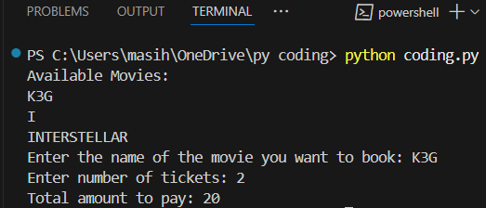
book_movie()
OUTPUT :

Q2. OOP Implementation – Library Management
- Create classes Book, Library, and User
- Library contains a collection of books
- User can borrow/return/view books
- Use class, constructor, inheritance, method overriding
ANSWER
class Book:
def __init__(self, title, author):
self.title = title
self.author = author
self.is_borrowed = False
def __str__(self):
status = "Borrowed" if self.is_borrowed else "Available"
return f"{self.title} by {self.author} - {status}"

class Library:
def __init__(self):
self.books = []
def add_book(self, book):
self.books.append(book)
def show_books(self):
print("\nLibrary Books:")
for book in self.books:
print(book)
def borrow_book(self, title):
for book in self.books:
if book.title == title and not book.is_borrowed:
book.is_borrowed = True
print(f"You borrowed '{book.title}'")
return
print("Book not available.")

def return_book(self, title):
for book in self.books:
if book.title == title and book.is_borrowed:
book.is_borrowed = False
print(f"You returned '{book.title}'")
return
print("Book not found or not borrowed.")

class User(Library):
def __init__(self, name):
super().__init__()
self.name = name

def show_books(self):
print(f"\n{self.name}'s View of Library:")
for book in self.books:
if not book.is_borrowed:
print(book.title)

my_library = Library()
my_library.add_book(Book("Harry Potter and the Sorcerer's Stone", "J.K. Rowling"))
my_library.add_book(Book("Twilight", "Stephenie Meyer"))
my_library.add_book(Book("The Curse of the Cheese Pyramid", "Geronimo Stilton")

user = User("Sheethal")
user.books = my_library.books
user.show_books()
user.borrow_book("Twilight")
user.show_books()
user.return_book("Twilight")
user.show_books()
OUTPUT:
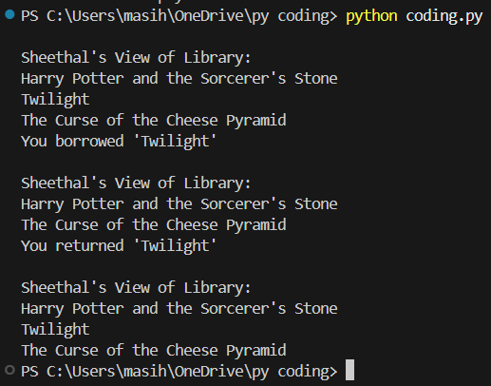

Section 2: Data Structures & Algorithms (30 mins)
Q3. Algorithm Problem – Minimize Coins (Greedy) (15 mins)
- Find minimum number of coins needed for a given amount
- Denominations: [1, 2, 5, 10, 20, 50, 100, 200, 500]
ANSWERS:
def minimize_coins(amount):
denominations = [500, 200, 100, 50, 20, 10, 5, 2, 1] # Sorted high to low
result = []
for coin in denominations:
while amount >= coin:
amount -= coin
result.append(coin)
return result
amount = int(input("Enter the amount: "))
coins_used = minimize_coins(amount)
print("Coins used to make", amount, "are:")
print(coins_used)
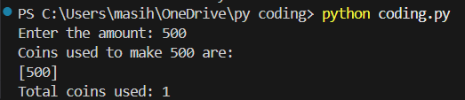
print("Total coins used:", len(coins_used))
OUTPUT :

Q4. Data Structure Usage (15 mins)
- Stack: Evaluate postfix expression '231*+9-'
- Linked List class: append(), display(), reverse()
ANSWERS:
def evaluate_postfix(expr):
stack = []
for char in expr:
if char.isdigit():
stack.append(int(char))
else:
b = stack.pop()
a = stack.pop()
if char == '+':
result = a + b
elif char == '-':
result = a - b
elif char == '*':
result = a * b
elif char == '/':
result = a // b # integer division
stack.append(result)
return stack[0]

class Node:
def __init__(self, data):
self.data = data
self.next = None

class LinkedList:
def __init__(self):
self.head = None

def append(self, data):
new_node = Node(data)
if self.head is None:
self.head = new_node
else:
temp = self.head
while temp.next is not None:
temp = temp.next
temp.next = new_node

def display(self):
temp = self.head
while temp is not None:
print(temp.data, end=" -> ")
temp = temp.next
print("None")

def reverse(self):
prev = None
current = self.head
while current is not None:
next_node = current.next
current.next = prev
prev = current
current = next_node
self.head = prev

expression = '231*+9-'
print("Postfix Expression:", expression)
print("Postfix Result:", evaluate_postfix(expression))

ll = LinkedList()
ll.append(10)
ll.append(20)
ll.append(30)
print("\nOriginal Linked List:")
ll.display()
ll.reverse(
print("Reversed Linked List:")
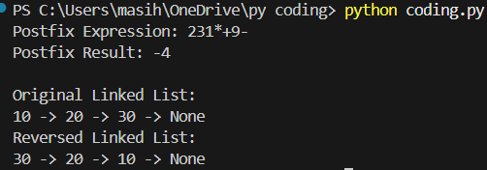
ll.display()
OUTPUT :

Section 3: SQL with Python Integration (30 mins)
Q5. SQL + Python – Student Scores Table
- Create table StudentScores(name VARCHAR, subject VARCHAR, marks INT)
- Insert sample data
- Use Python to display records, show average marks, list students scoring <40
ANSWER :
import sqlite3
conn = sqlite3.connect("students.db")
cursor = conn.cursor()
cursor.execute('''
CREATE TABLE IF NOT EXISTS StudentScores (
name TEXT,
subject TEXT,
marks INTEGER
)
''')
cursor.execute("DELETE FROM StudentScores") # Clear table if already exists
sample_data = [
('Aarav', 'Maths', 88),
('Riya', 'Science', 76),
('Kabir', 'English', 35),
('Ananya', 'Maths', 91),
('Vivaan', 'Science', 29),
('Meera', 'English', 47),
('Rohan', 'Maths', 38)
]
cursor.executemany("INSERT INTO StudentScores (name, subject, marks) VALUES (?, ?, ?)", sample_data)
conn.commit()
print("All Student Records:")
cursor.execute("SELECT * FROM StudentScores")
for row in cursor.fetchall():
print(row)
print("\nAverage Marks:")
cursor.execute("SELECT AVG(marks) FROM StudentScores")
avg = cursor.fetchone()[0]
print(f"{avg:.2f}")
print("\nStudents with marks less than 40:")
cursor.execute("SELECT name, subject, marks FROM StudentScores WHERE marks < 40")
for row in cursor.fetchall():
print(row)
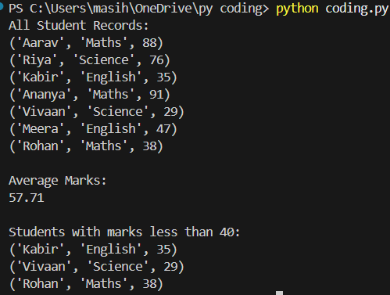
conn.close()
OUTPUT :

Section 4: Version Control with Git (10 mins)
Q6. Git Challenge
- Initialize Git repository
- Create and switch to branch feature/students
- Add and commit your Python code
- Merge feature/students into main
- Provide Git commands
ANSWERS :
git init
git checkout -b feature/students
git add .
git commit -m "Add student scores program"
git checkout -b main
git merge feature/students
git branch -d feature/students
git remote add origin https://github.com/shee-26/student-scores.git
git push -u origin main
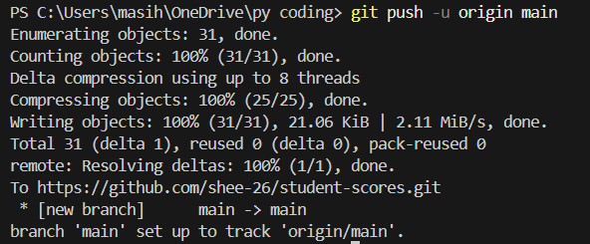
OUTPUT :

Bonus Section: PyUnit Test Case (10 mins)
Q7. PyUnit test cases for Q1 (Booking System)
- 1 test case for calculate_amount()
- 1 test case for booking() using mocks if needed
- Use unittest.TestCase, setUp(), tearDown()
ANSWERS :
movies = {"Harry Potter": 150, "Twilight": 120, "Geronimo Stilton": 100}
def calculate_amount(movie, tickets):
return movies[movie] * tickets
def booking(movie, tickets):
if movie in movies and tickets > 0:
return f"Booked {tickets} tickets for {movie}"
else:
return "Booking failed"
import unittest
class TestMovieBookingSystem(unittest.TestCase):
def setUp(self):
print("Setting up test environment...")
def tearDown(self):
print("Cleaning up after test...")
def test_calculate_amount(self):
result = calculate_amount("Harry Potter", 2)
self.assertEqual(result, 300)
def test_booking_valid(self):
result = booking("Twilight", 3)
self.assertEqual(result, "Booked 3 tickets for Twilight")
def test_booking_invalid(self):
result = booking("Unknown", 2)
self.assertEqual(result, "Booking failed")
result = booking("Harry Potter", 0)
self.assertEqual(result, "Booking failed")
if __name__ == '__main__':
unittest.main()
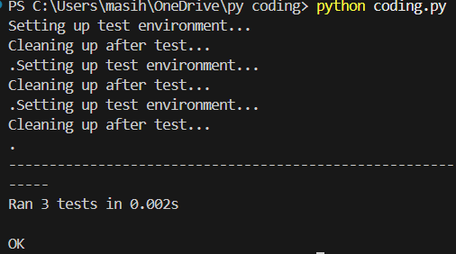
OUTPUT ;

